**Provider admin and disconnect with advisers - blockers to getting the job done say paraplanners – the lang cat research**

* Annual ‘State of the Advice Nation’ study explores paraplanning for the first time, reflecting the growing contribution of profession
* Provider admin and disconnect with advisers present the biggest blockers to the job on a daily basis (49%)
* Almost half (48%) believe paraplanner roles are poorly defined

The lang cat has launched its sixth annual State of the Advice Nation (SOTAN) report, and today shares for the first time, findings relating solely to the paraplanning profession.

The findings reveal that half of paraplanners (49%) believe their roles are poorly defined. And, when paraplanner respondents were asked what they see as the main blockers to doing their jobs effectively each day, a disconnect with advisers on what they should be doing, was the second most common response (for 42%). Clearer role definition on the back of open conversations, therefore, may help to address this significant challenge.

Graph – How well defined are paraplanning roles in the sector?

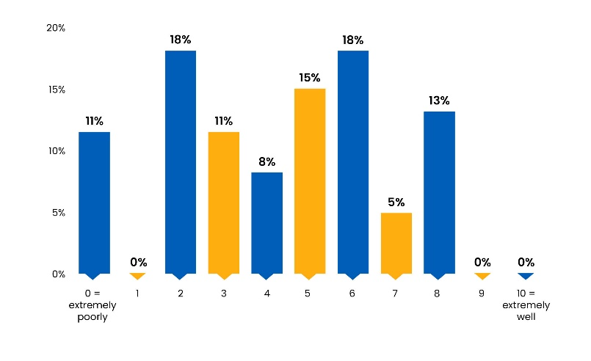

Graph – biggest inhibitor of you doing your job to the best of your ability on a daily basis?

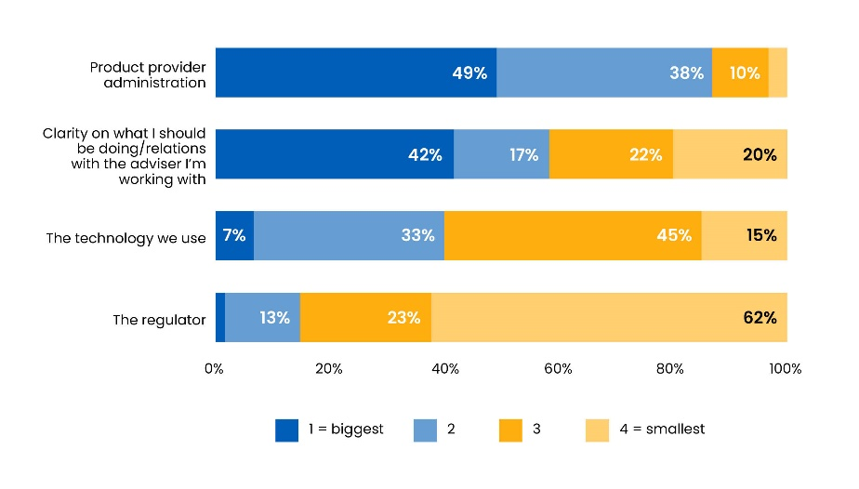

The leading blocker, perhaps unsurprisingly, is provider administration for half of paraplanners (49%). When asked for open comments on how providers could help, the largest chunk of responses focused on the need to deliver information needed about legacy contracts and letter of authority requests to support customers with swifter service.

Another dominant theme that emerged was how paraplanners feel providers view their roles with some calling out a perceived lack of understanding of the different paraplanning models.

Overall, when asked in what regard paraplanners feel their role is held, they believe they are viewed in the same esteem as those running the advice profession and amongst providers. In contrast, this is not the case for the regulator, where the sector believes it is held in negative regard. And similarly, in neutral regard by the investment arm of the financial services industry.

GRAPH In what regard do you feel the paraplanning role is held?

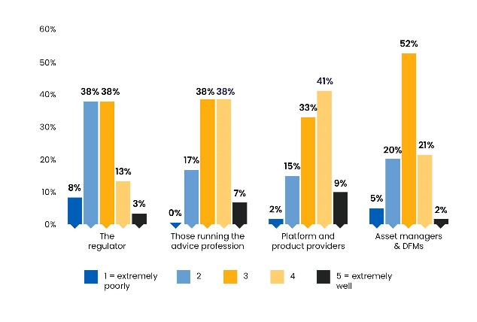

Reinforcing business owner recognition of paraplanners’ contribution – as well as paraplanners themselves – both believe that as a minimum, diploma level qualifications are vital, as well as for those in client facing roles. There is agreement too that for client facing roles, a higher level of qualification is needed.

Graph – View on qualifications

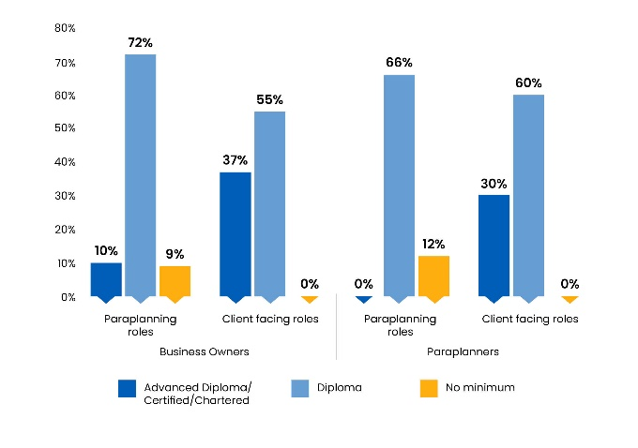

The findings show the paraplanning community feeling confident in the face of technological change and in particular, around the emergence of AI. Just under 40% are bullish that it is not a concern or if anything they welcome it and believe it will help their role. The findings suggest this might be in the form of doing some of the heavy lifting around data aggregation and report writing.

Graph – concerns around AI

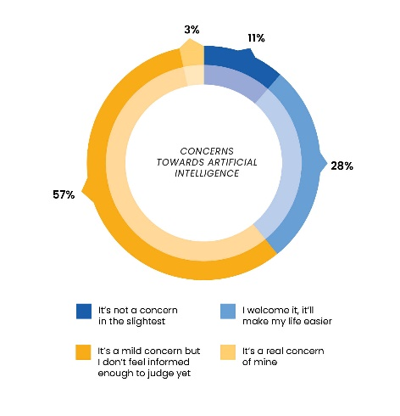

**Steven Nelson, insight director and the other co-author, says**: “A deep dive into the profession is long overdue and the fact that findings are split out for different roles including paraplanners, advisers, and business owners is reflected in the report’s new name.

“The fact that so many paraplanners believe their roles are poorly defined, is a real concern and one where the whole sector must work together to address. There is a clear need for open and honest conversations to ensure firms are making the most of valuable skills and expertise.  This is a no brainer, given that one of the main findings relating to advice firm owners is that workload is keeping them awake at night.

“On the flip side, it’s reassuring to see so many embrace the potential of tech and AI – particularly if they see it as freeing them up to focus on other priorities.”

The research is one of the largest advice-focused attitudinal studies in the UK with 400 members of the advice profession taking part. The findings will be shared throughout 2024.

**For further information, contact:**

Nicola Cannings, PR Director, the lang cat

T: 0771 366 9899

email: [nicola@thelangcat.co.uk](mailto:nicola@thelangcat.co.uk)

**Notes to editors:**    
The lang cat is Leith’s leading (probably) specialist financial services consultancy. The lang cat works with financial advisers and providers, helping them develop new propositions, turn marketing strategy into action and articulate their services in such a way that people without financial services degrees have a hope of understanding them. It aims to make the industry a little bit less corporate and stuffy and a little bit more human.