**8 February 2024**

**Fears of further regulation keeps advice firm owners awake at night ‘volume and pace difficult to contend with’ – the lang cat research**

* Fears of further regulation and workload cause sleepless nights for business owners
* Over a third (38%) of advisers readjusted financial plans for over one in ten clients in 2023
* A third of firms predict growth in 2024
* Consolidation trend continues - 14% considering selling businesses

The lang cat launches its sixth annual State of the Advice Nation (SOTAN) report, today. Its first tranche of findings reveals that, during the year of Consumer Duty implementation, fears of further ‘compliance and regulation’ is the main issue keeping a third (31%) of advice business owners awake at night. Many expressed concerns about the pace and volume being difficult to contend with.

On top of the burden of regulation, fear of failing to meet client expectations is causing sleepless nights for one in ten. This issue features more prominently than in previous years reflecting hostile markets. Respondents talked about a lack of acceptance from clients about lower returns and delivering tough messages about the impact on retirement plans.

**What’s keeping advice firm owners awake at night?**

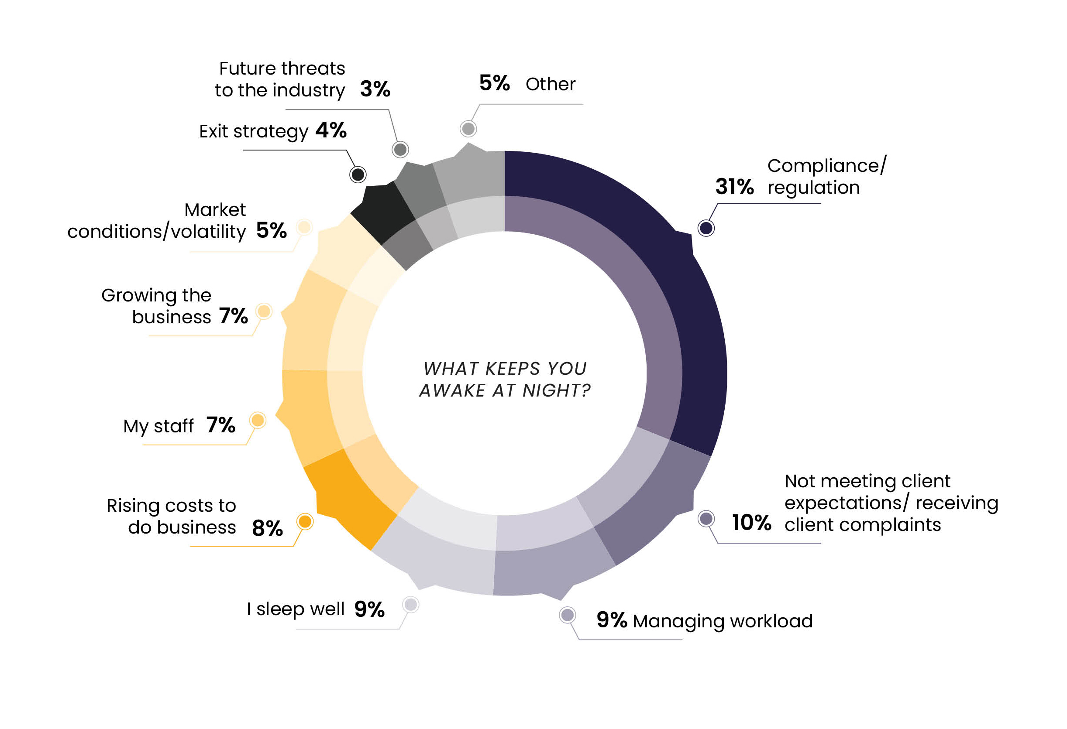

Pressure and workload are also causing unrest and having too few hours in the day to get everything done (9%). This is likely to be exacerbated by the ongoing cost-of-living crisis pressures with over a third (38%) of respondents saying they’d materially adjusted financial plans for one in ten clients last year. The main drivers behind these changes are higher household expenses and fears about markets.

**Reasons for financial plan adjustments**

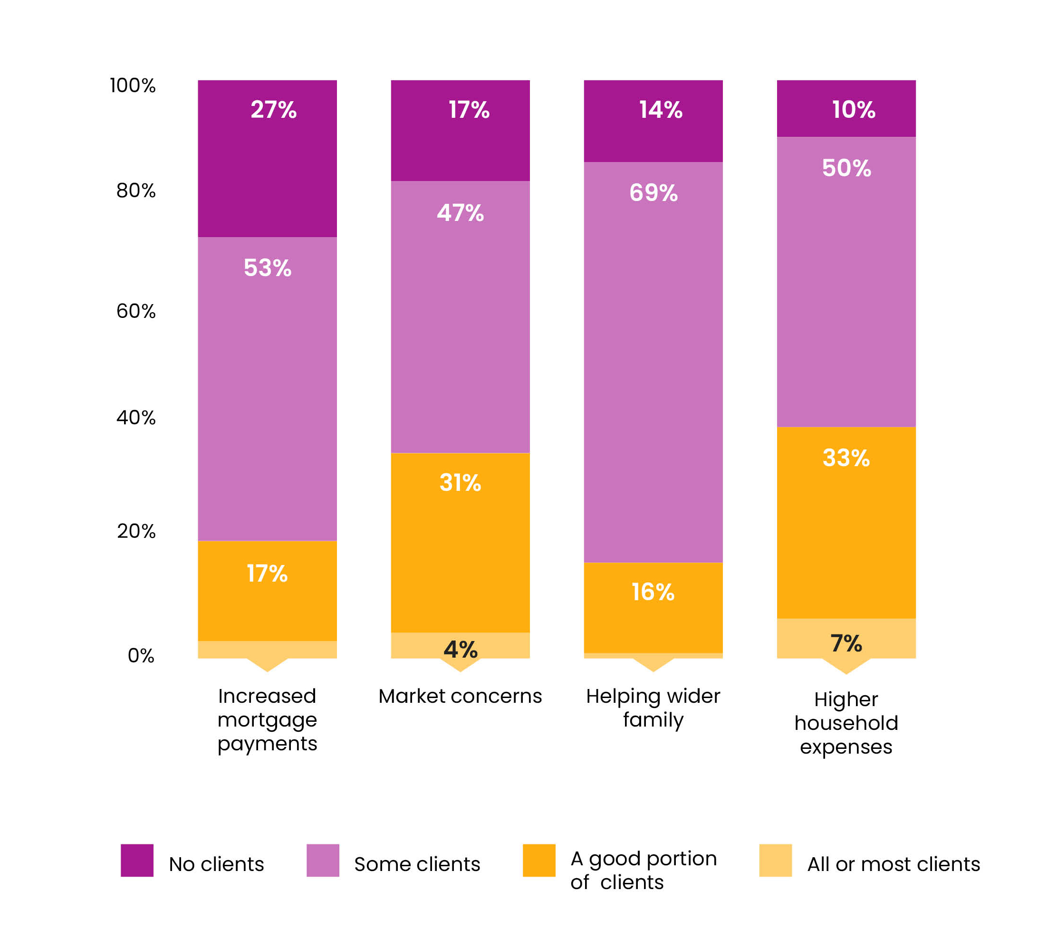

Close behind unmanageable workloads as a cause of stress, is the rising cost of doing business for 8% - linked to regulatory fees, increase in tech budgets and the consequent hit on profit margins.

But it seems that advisers are increasingly leaning into to tech and AI with a third of the advice industry saying there are either currently using AI or intend to do so within the next year. This number rises to over half (58%) if we look forward five years.

**Advisers embrace AI**

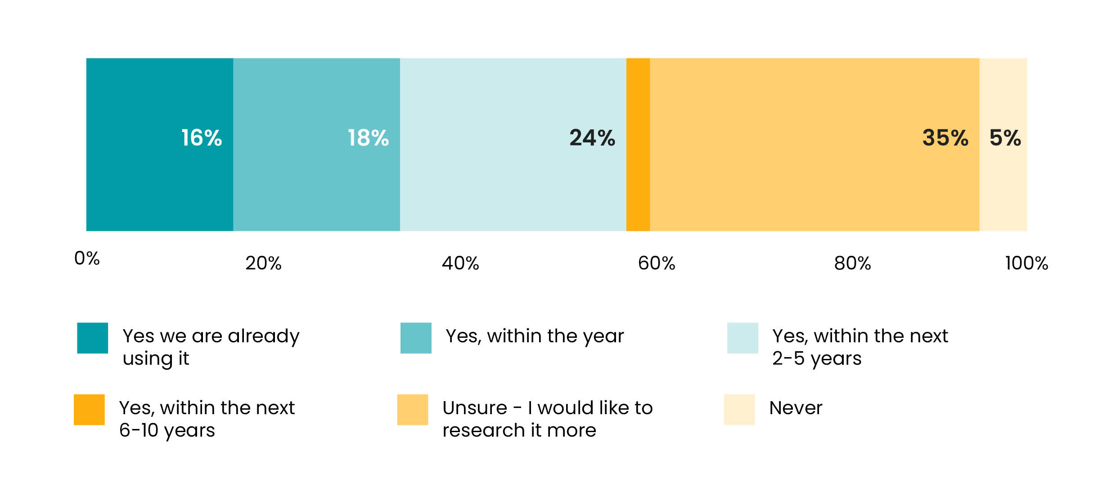

Despite volatile markets driving record client withdrawals last year, alongside monumental regulatory change, a third of firm owners are feeling bullish and predict growth. Most report 2023 as the toughest year in decades but turnover and profit are holding up.

**Advice firm turnover and profit**

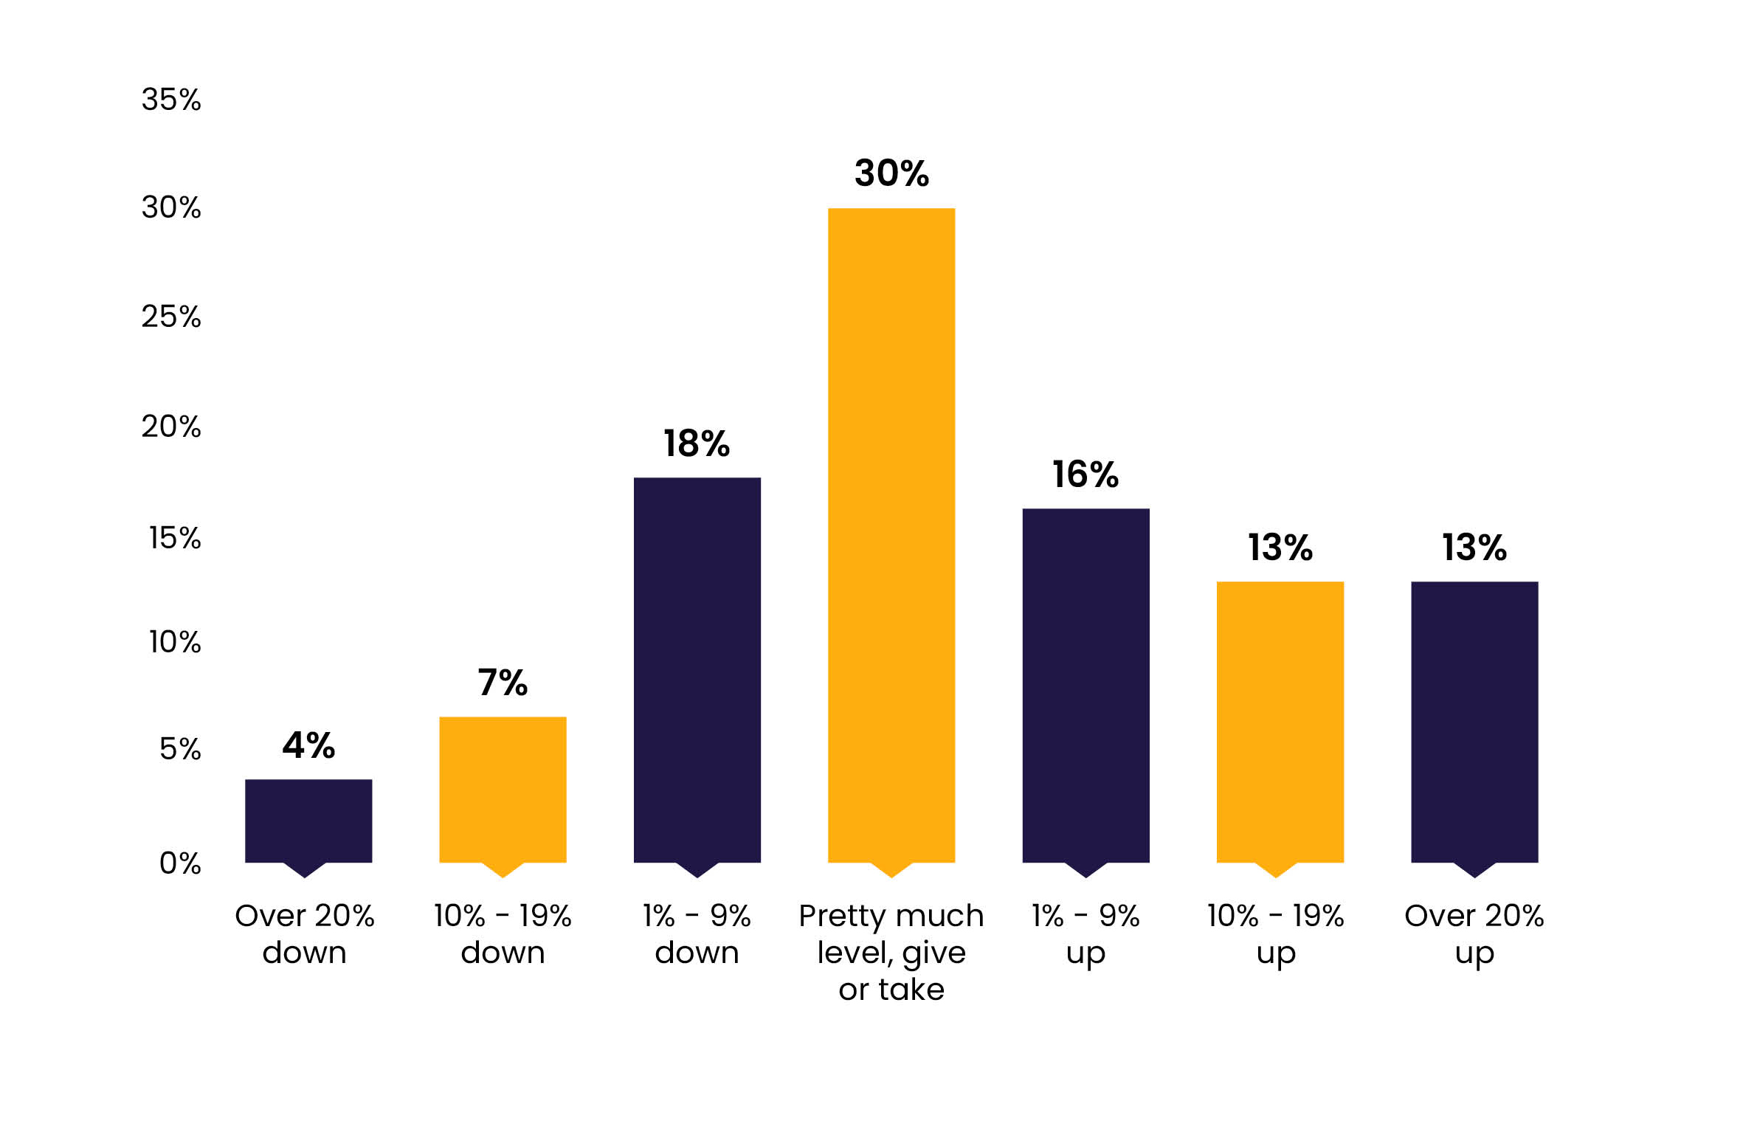

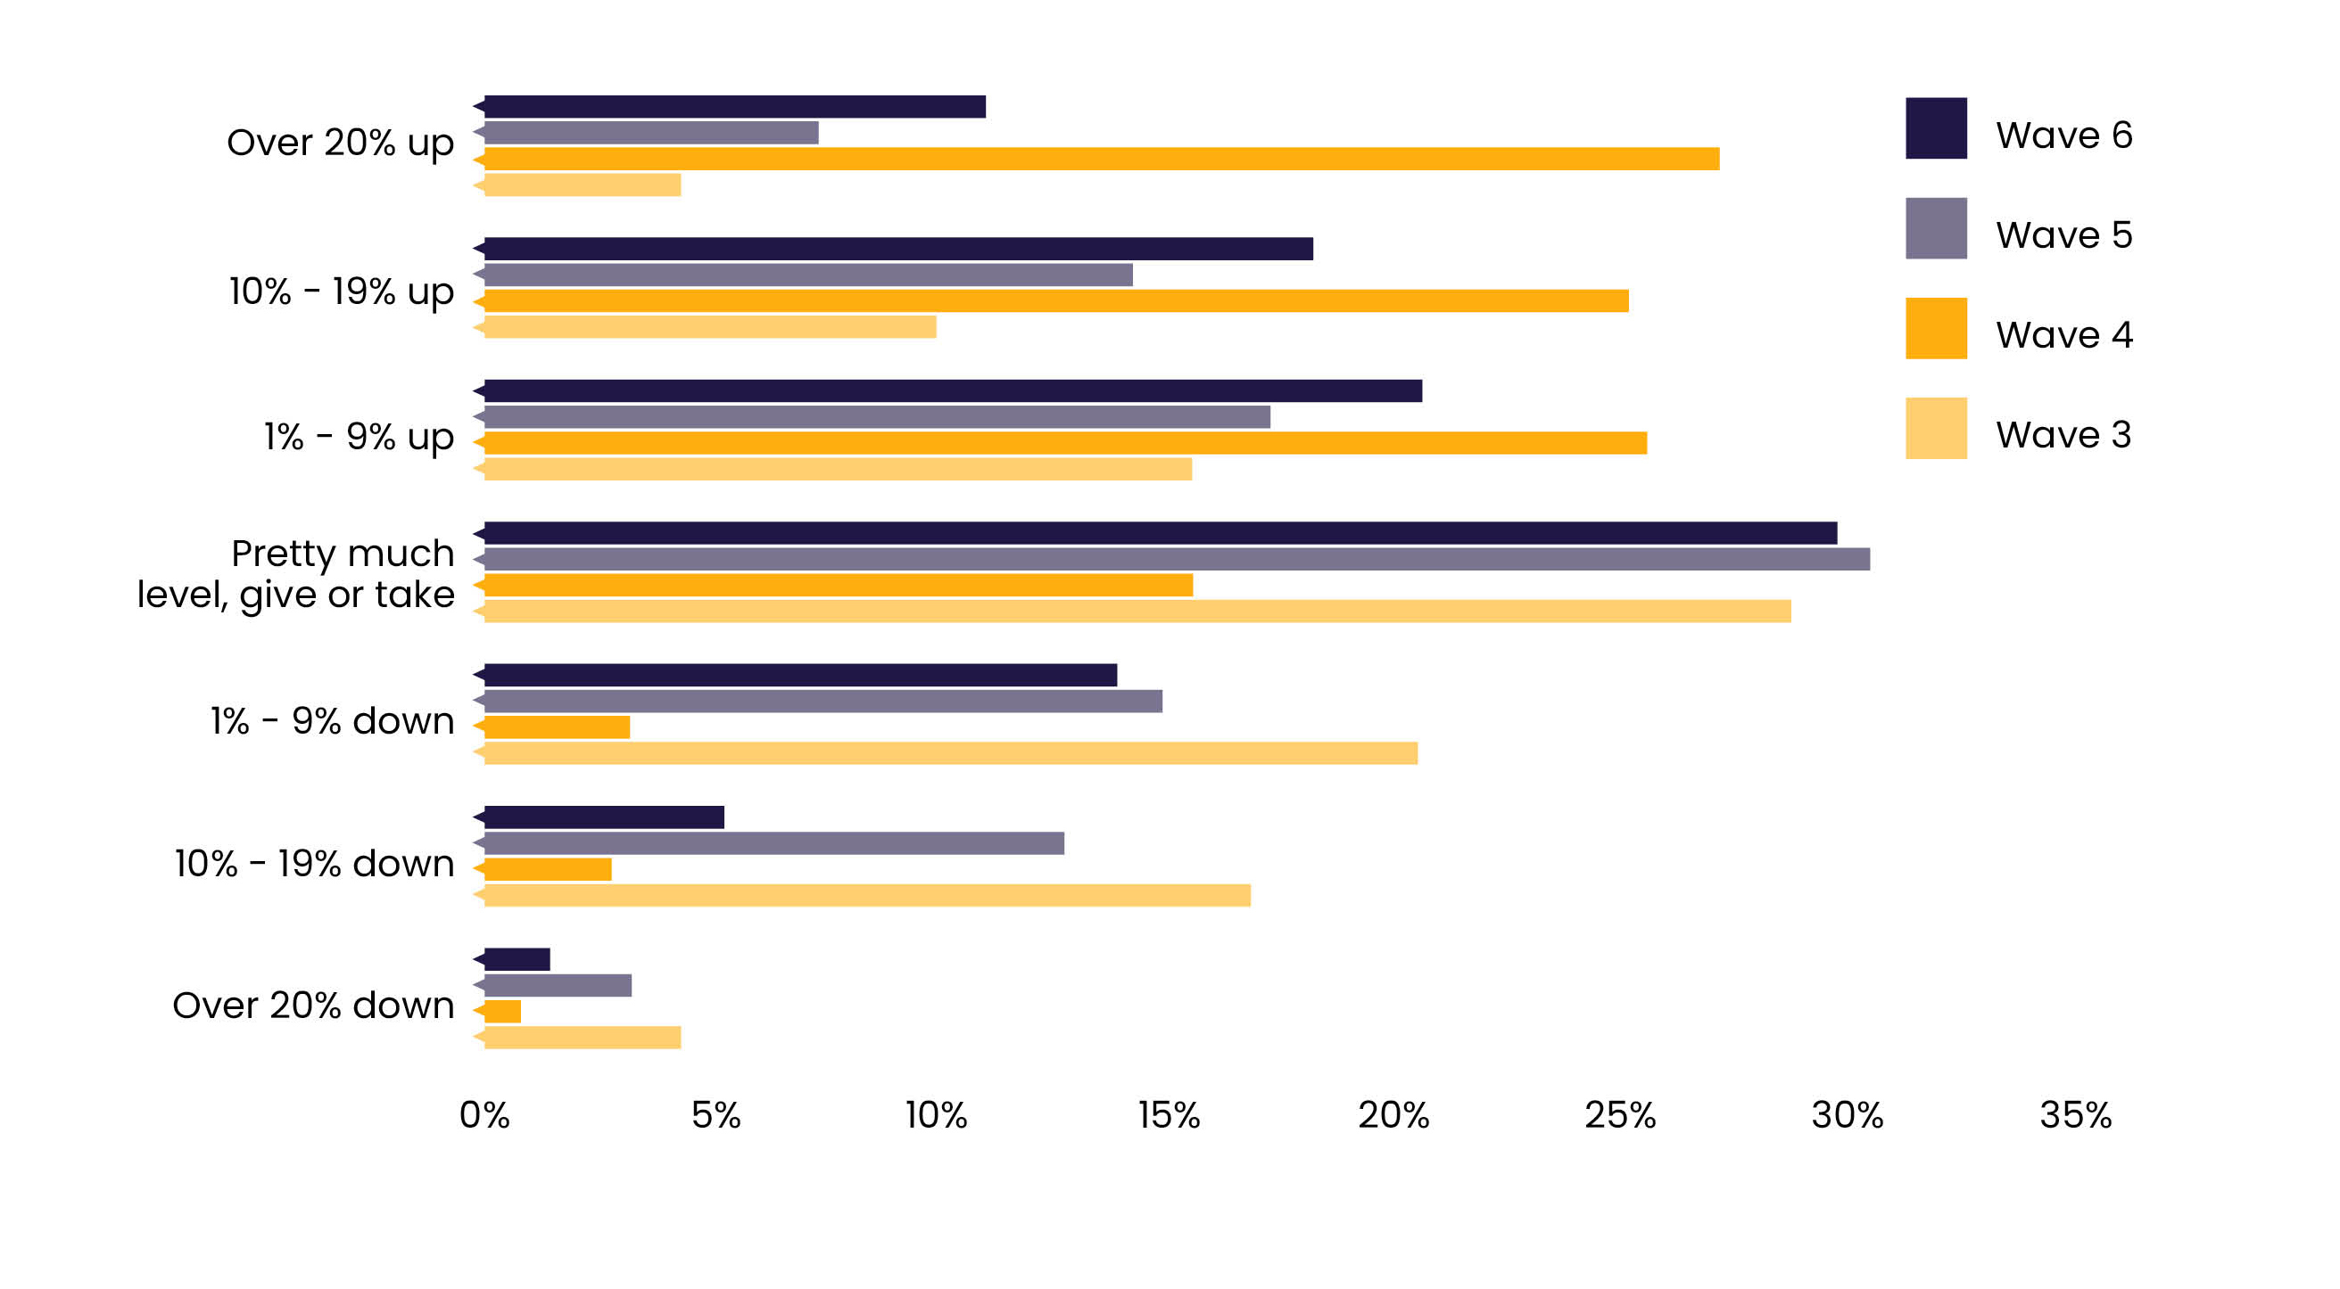

Looking at future business ownership, consolidation trends continue with 14% considering selling to a consolidator in future, with this figure jumping to a third for those aged 65 and over. There is also a notable drop in the number of business owners that see themselves owning the business in five years, stressing the need to entice new talent into the industry.

**Future business ownership**

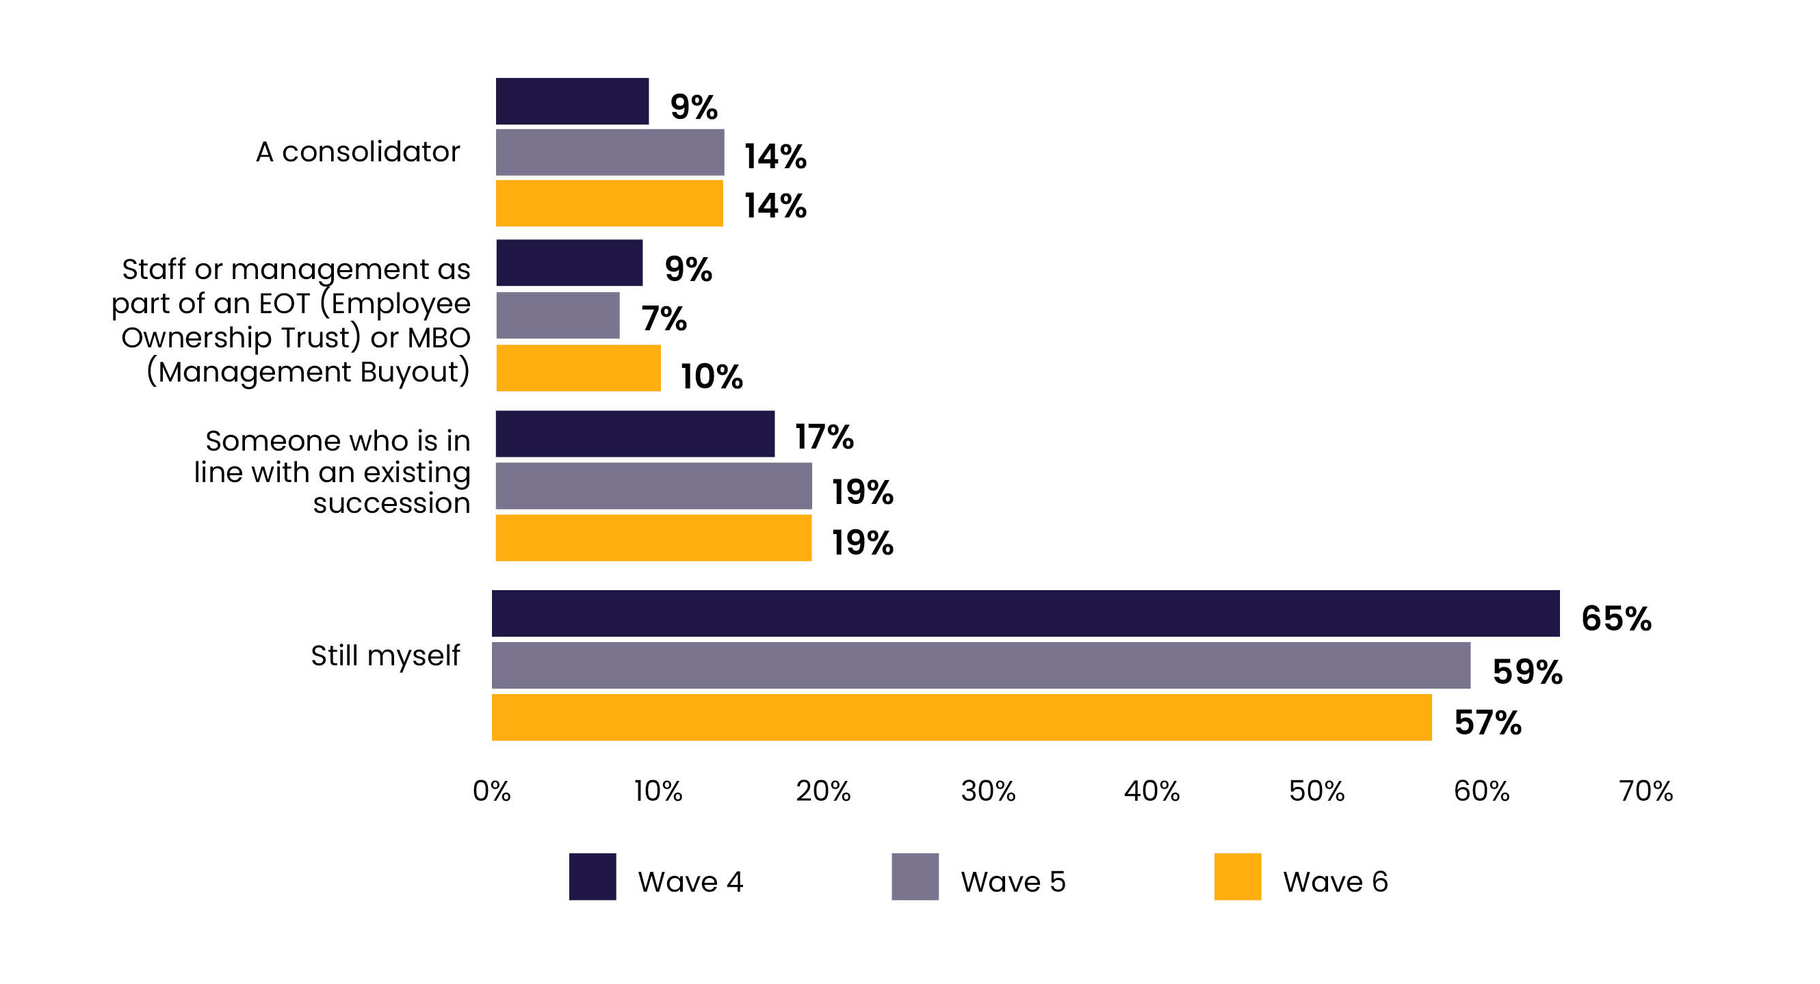

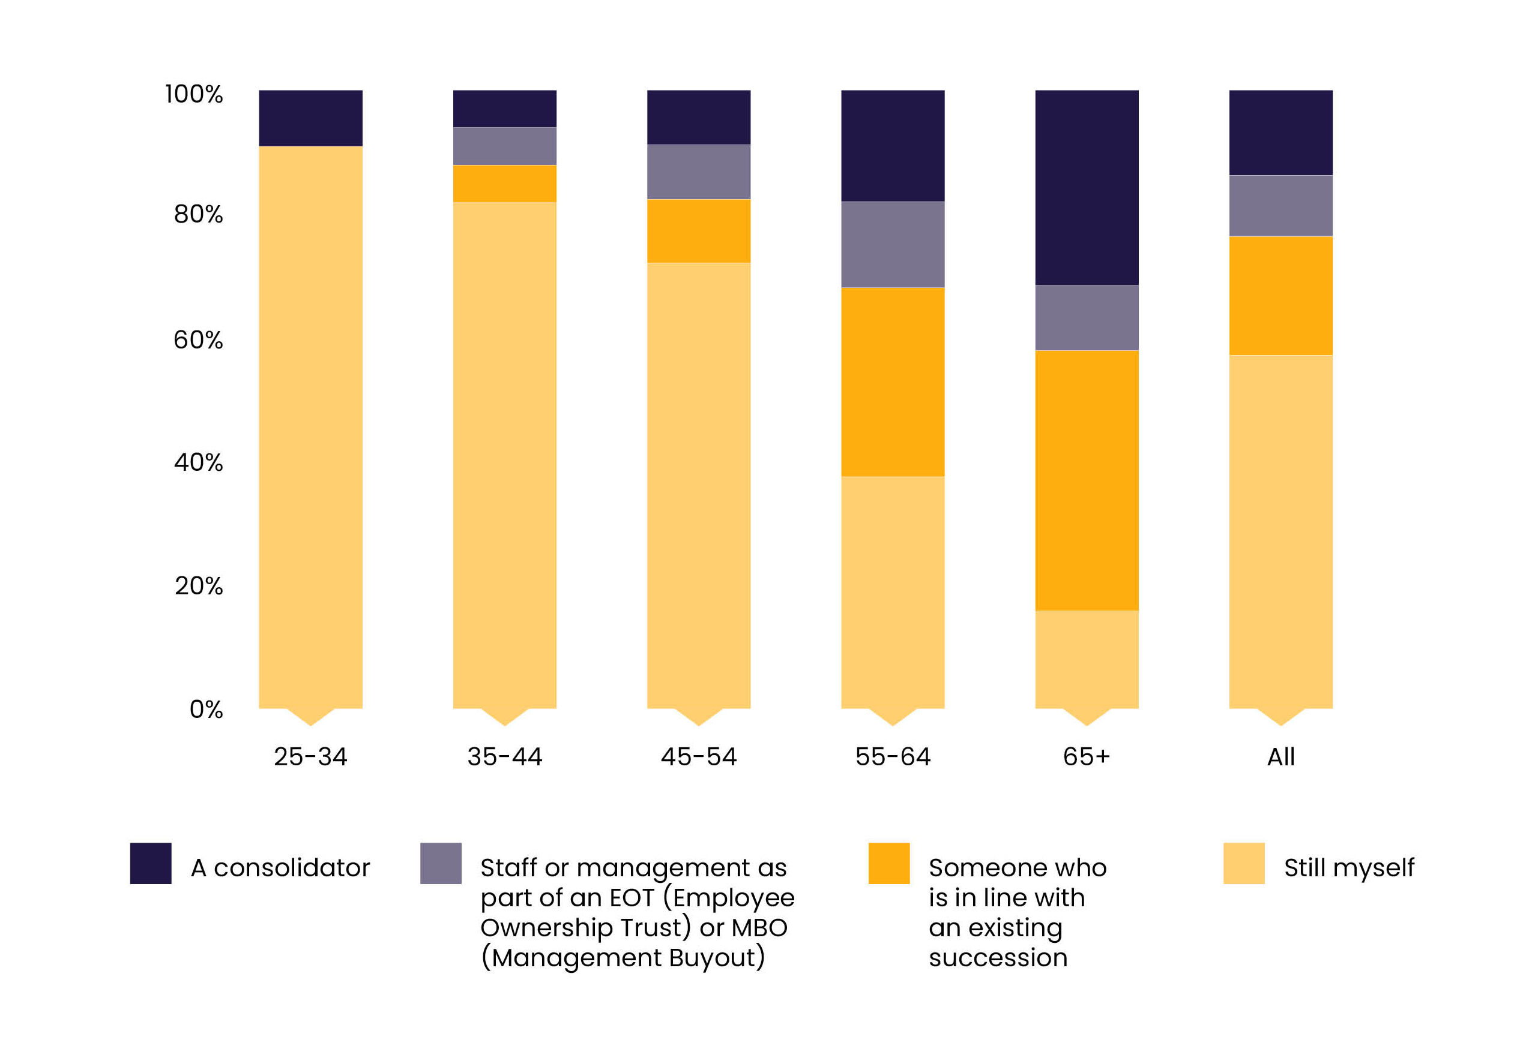

In a SOTAN first, findings are split out for different roles including advisers, paraplanners and business owners which is reflected in the report’s new name. It also includes a deep dive into the paraplanning profession. Headline findings show nearly half (49%) of paraplanners believe their roles are poorly defined, highlighting the need for open and honest conversations to ensure firms are utilising valuable skills and expertise. The lang cat will be publishing further details later this year.

**Steven Nelson, insight director and the other co-author, says**: “The burden of regulation continues to be a massive headache for firms and it’s a real concern to see this driving some to breaking point. Many respondents from smaller firms talked about the disproportionate impact on them.

“On the flip side, it’s reassuring to see so many embrace the potential of tech and AI – particularly if they see it as freeing them up to focus on other priorities. Frustrations remain with other tech and the ongoing issue of integration, but we’ll share more on this later in the year.”

The research is one of the largest advice-focused attitudinal studies in the UK with 400 members of the advice profession taking part. The findings will be shared throughout 2024.

**For further information, contact:**

Nicola Cannings, PR Director, the lang cat

T: 0771 366 9899

email: [nicola@thelangcat.co.uk](mailto:nicola@thelangcat.co.uk)

**Notes to editors:**The lang cat is Leith’s leading (probably) specialist financial services consultancy. The lang cat works with financial advisers and providers, helping them develop new propositions, turn marketing strategy into action and articulate their services in such a way that people without financial services degrees have a hope of understanding them. It aims to make the industry a little bit less corporate and stuffy and a little bit more human.