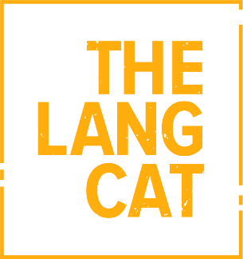
PRESS RELEASE

24 June 2026
Afternoon wins AdviceTech Catwalk 2026
The winner of AdviceTech Catwalk 2026 is Afternoon, an AI powered operating model which automates the advice process, the lang cat can reveal.
Afternoon, which attempts to use clean, connected data across the whole process from meeting capture, through to suitability reports, won the tight competition that was decided by just two votes.
The company competed amongst four other early-stage propositions, Planbot by ammonite, Obsidian, Life After Me and Eddie by Jigsaw Tree at the event.
They had a strict five minutes to demo their wares before being questioned by industry-expert high inquisitors and an adviser audience, before the advice professionals voted on their best in show.
The High Inquisitors included Felicia Meyerowitz Singh, NED and co-founder of Engage Smarter AI, along with FNZ managing director James Dunne and ZeroKey co-founder and CEO Joseph Williams (the inaugural Catwalk winner in 2024).

Catwalk is an annual Dragons’ Den style event run by the lang cat, which is billed as an opportunity for early-stage advice, wealth and fintech propositions to display the wares they believe will help shape the advice sector in the future.
Natalie Holt, head of content at the lang cat, said: “We see new technology appearing all the time, but Catwalk is about trying to recognise those at an earlier stage in their development who have something that could positively impact the advice profession in years to come.
“Afternoon are demonstrative of that. Their product answers a problem advisers face which holds them back from doing what they do best – advice.
“Catwalk is about giving advice professionals the chance to see AI up close, and tech they wouldn’t necessarily see elsewhere. It’s about asking the questions they want answered before embedding new systems in their business.
“This means that the final vote is always going to be one of confidence in that firm.”
Crawford Taylor, CEO and founder of Afternoon, said: “It’s great to get recognition from your audience, and for advisers to vote us best in show amongst such competition is a real result.
“The five minutes passed so quickly, I felt the system had more to show, but I am glad enough came across to show its core value.

“The advice industry is evolving all the time, and tech is a big part of that.”

- Ends -

For further information, contact:
Sean McKinven, PR Account Executive, the lang cat
T: 0131 376 6244
email: sean@thelangcat.co.uk

Notes to editors:
The lang cat is Leith’s leading specialist financial services consultancy and PR agency. The lang cat works with financial advisers and providers, helping them develop new propositions, turn marketing strategy into action and articulate their services in such a way that people without financial services degrees have a hope of understanding them. It aims to make the industry a little bit less corporate and stuffy and a little bit more human.

